Scott Glauser’s Top Ten Emergency Preparedness Items
in order of importance

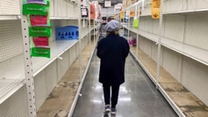 | Food, Water & Etc Get at least a month’s supply things you use daily. Food, water, soap shampoo etc. Store at least 2 liters of water per person per day. Remember, toilet paper is always the first thing to disappear from store shelves.
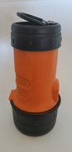 | Larger LED Flashlight This is the best emergency flashlight you can own for any amount of money. An average flashlight goes 7 hours on a set of 2 D cells. This one goes over 43 hours on a set of 4 AA batteries. The LED bulb is rated at 100,000 hours. It works completely under water, has a flat bottom, so it can stand on end, has a “one hand” operation switch, a ring to hang it up with, and it floats face up.
 | Battery Powered Radio Most radios run 10 to 80 hours on batteries. “Boom Boxes” are the worst. A radio like this runs over 100 hours on one set of 4 “AA” batteries. It has AM/FM and Weather Band. It has an earphone jack, and works on AC or Batteries. Good quality sound for its small size.
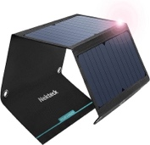 | Solar Charger. This device has several USB ports. It can charge your cell phone and rechargeable AA batteries for use in your flashlights, lanterns and radios.
 | Lantern LED bulbs last an average of 100,000 hours, and use much less power than normal bulbs or fluorescent tubes. Most fluorescent camping lanterns will run 6 hours on a charge. Propane camping lanterns also run about 6 hours on a single 16 oz propane bottle. This lantern is brighter than a twin tube fluorescent lantern, and will run an amazing 24 hours on a single set of 3 AA batteries. The extended run time makes it perfect for emergencies. You may need several of these.
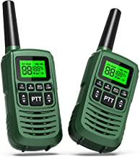 | 2-Way Radio In a citywide power outage, cell towers have enough battery backup to operate for 2 to 4 hours. After that, the FRS or GMRS radio can be used to communicate with others who have these radios. Distances vary widely but some of these can go several miles.
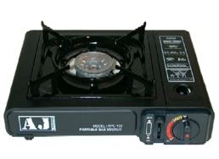 | Gas Stove Most camping stoves are not safe to use indoors. In addition, white gas “pump up” stoves, and propane gas stoves take a lot longer to set up and are messy and difficult to use. This one is easy to setup and use, has electric ignition that works without batteries, is safe to use indoors, cooks like a regular gas stove, has easy to change butane fuel cans, and is UL approved. This stove will run about 1.5 hours on high on one can of fuel. When cooking food, the flame is lower and it will go much longer. Fuel is sold in 4-Packs. A case is 28 cans.
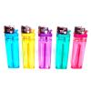 | Lighter A disposable, butane lighter doesn’t cost very much and is equal to thousands of matches. It will also work after being wet. Get the one with a flint and wheel.
 | Cash In a citywide power outage, some stores may remain open. They will not take credit cards or checks. You should keep at least $100 in cash at all times. One-dollar bills are best.
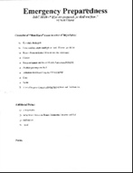 | List of Things To Take. If you must leave home on short notice, you will need a list of Important things to take with you. If you’re going to a friend’s house or a shelter, you’ll need a bag with extra clothes, toothbrush and other personal items. If your house is in danger, you’ll also need your photographs and important papers. When people’s houses are destroyed they always say the same thing afterwards, “Everything was replaced except our photographs.” Make a list in order of importance, and tape it to the back of your bedroom door.

